EVAN BROWN – Texturing
https://github.com/EvanBrown-Git/Essentials/blob/main/DAGV1100and1200/Maya/scenes/Diorama/Diorama%2019.ma
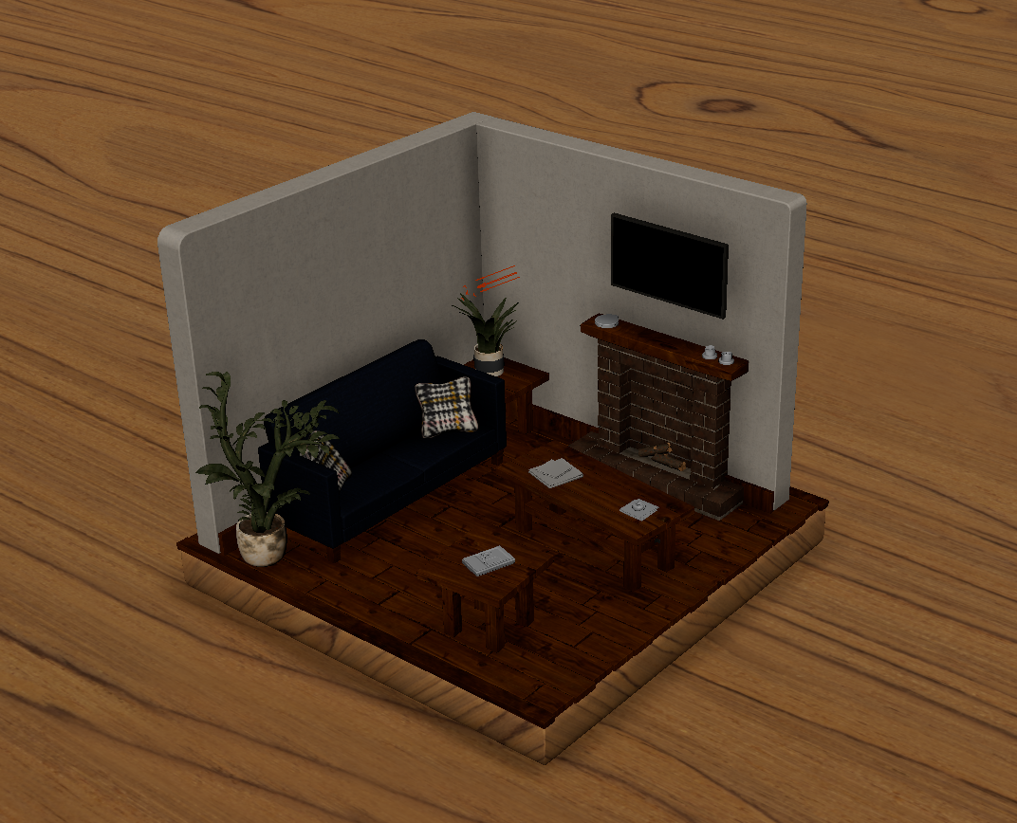
All the textures that I used were from PolyHaven

For the all of the planks, I found a darker polished wood texture. The hardest texture to find was the texture for the paper, I used the moondust texture, but it was too grey so I used a color node and a blend colors node to mix it with a creamier color. While texturing the bricks and planks, I realized that they were experiencing heavy tiling, so I went into UV unwrap mode and just moved the shells around to create some randomness. In this process, I found the UV shell select option to be very helpful.

